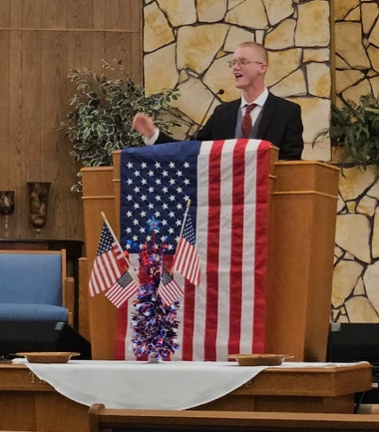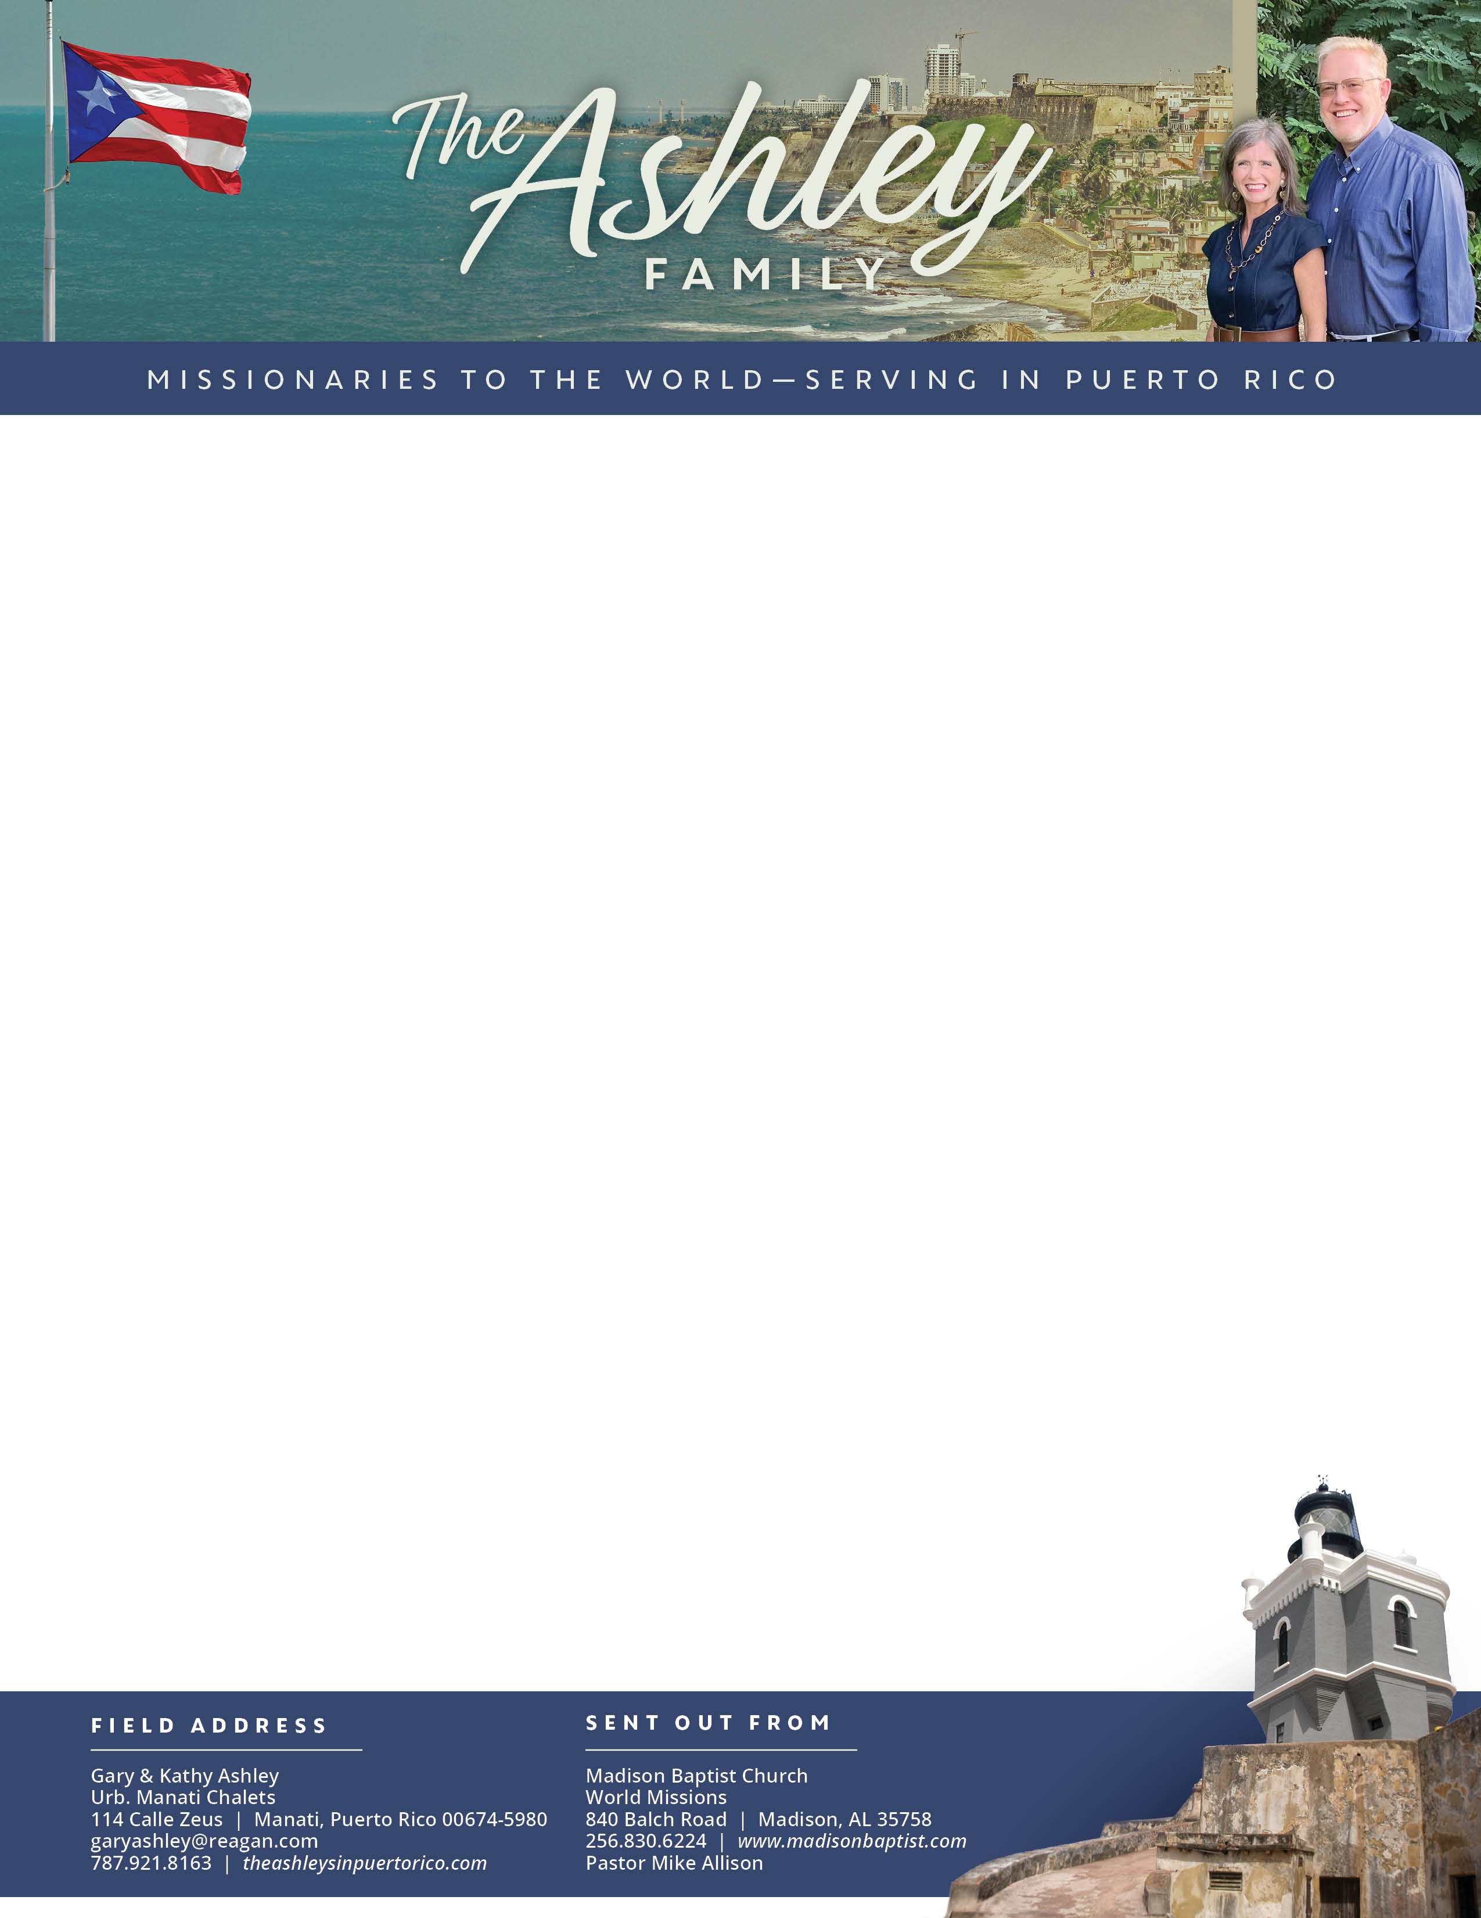

Gary Ashley

*Alaba al Señor*,

(Praise the Lord)

Prayer Requests: 1. Mabel in the passing of her mother. 2. Abraham with the care of Juana. 3. Rosemary and her sister Shirley as they deal with their infirmed mother. 4. Stephen in Bible college.

Dear Praying Friends, July / August 2024

**Colossians 3:3 “For ye are dead and your life is hid with Christ in God.”**  Christ did not die just so that I might live, but rather He died so that I might die, and He lives so that I might live. We already have died the only death that counts, and we already have life that will lead to more life. This month we mourned the loss of Mabel’s mother but rejoice that one day we will see her again. While there is sadness, there was joy in that her mother was with Christ and she had no worries about sin or guilt. Now, she enjoys a life that was given at the resurrection of Jesus, added to her at regeneration, and is now much fuller since she is in the presence of Christ.

**International Evangelization Efforts:** Our church missionaries in Venezuela, Klixon Castillo in Valencia and Luis Quilarque in Guacara and surrounding areas are serving even in the midst of the most turbulent times. There is great persecution and oppression, but the light of the glorious Gospel shines even brighter. Please pray for protection for them, their families, and the believers that are there. Klixon is working on a visa for his daughter and will have to travel to Europe to try to obtain one. Please pray for these missionaries and the works there.

**Personal News:** We are excited to state that Stephen is back from his summer job in Kansas working on a road crew saving finances for this second year of Bible college He has returned to Heartland Baptist Bible College for his sophomore year. The Lord provided him a great car, 2004 Buick Century with 114,000 miles, his driver’s license, and eye exam with new, improved glasses. He is excited and motivated for this new year. Please pray for God’s will in his life.