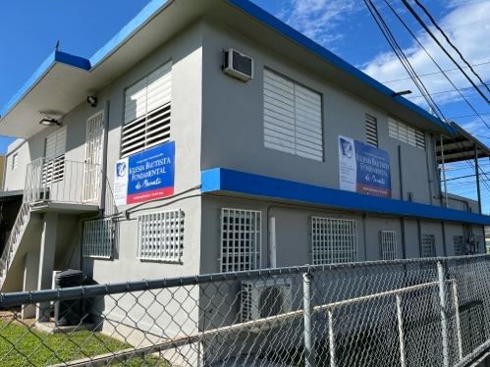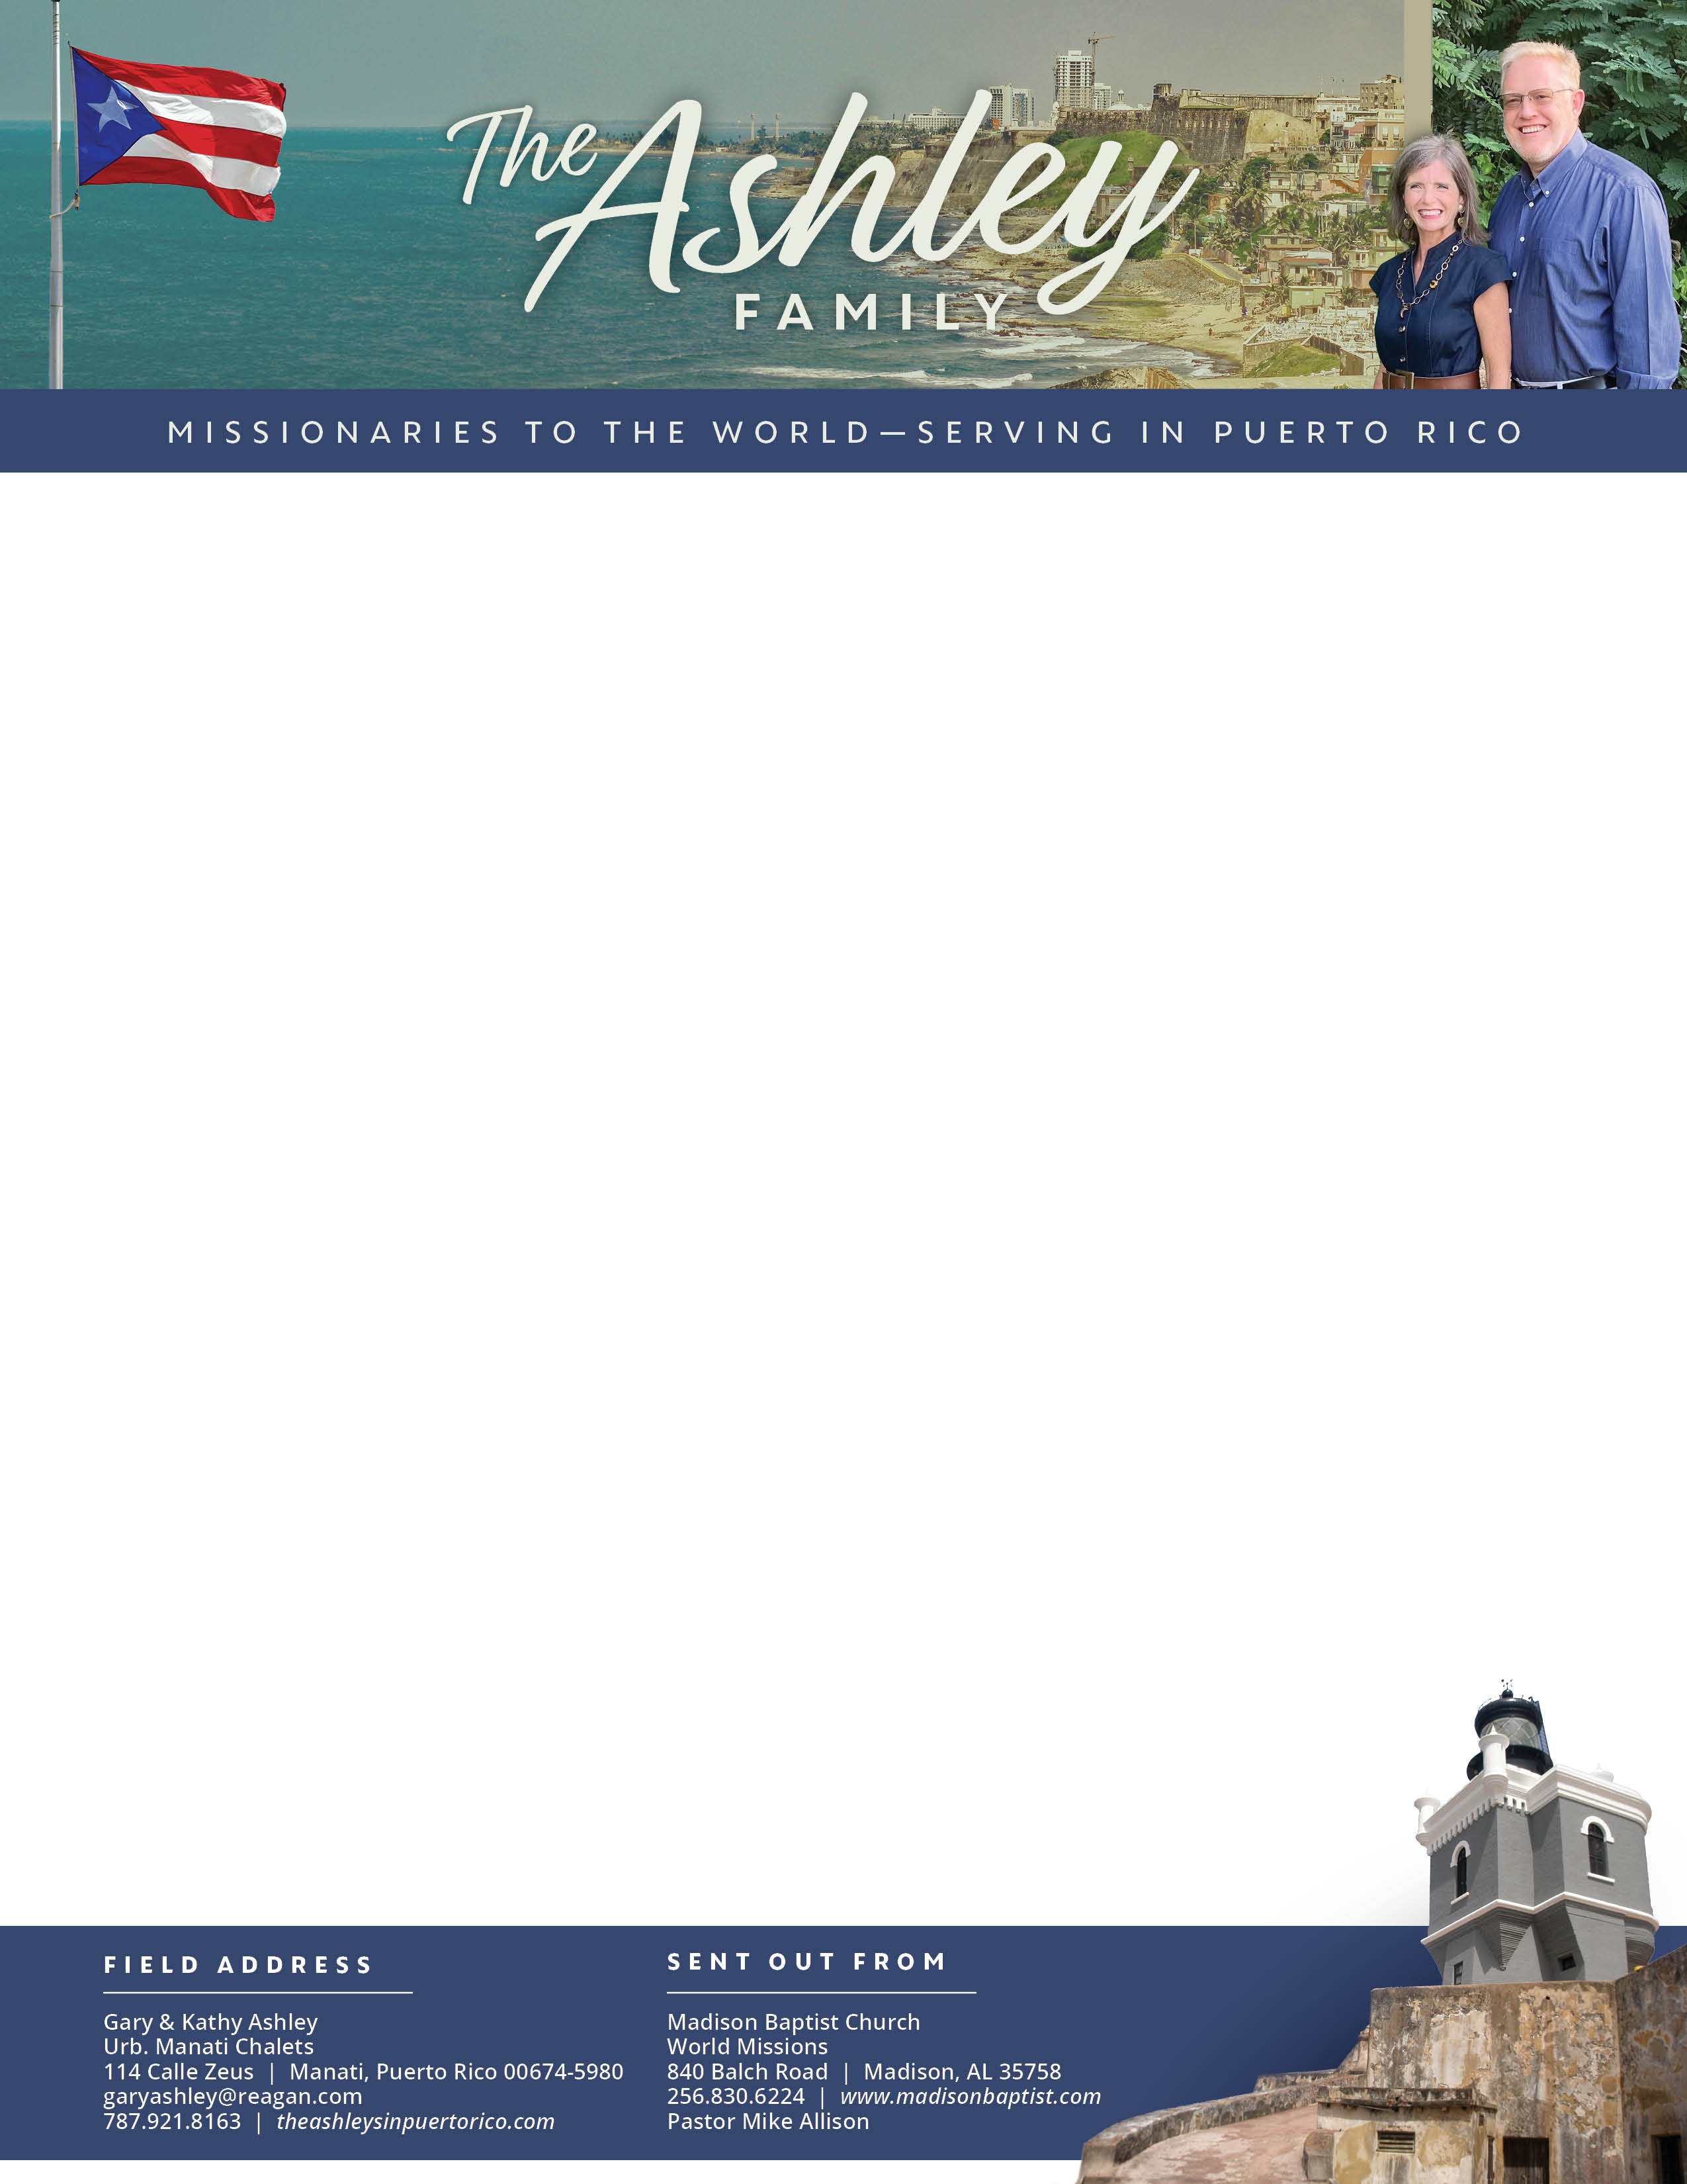

Gary Ashley

*Alaba al Señor*,

(Praise the Lord)

Prayer Requests: 1. Rosemary in the passing of her mother 2. Abraham with the care of Juana 3. Mildred has been visiting since her mom fell and broke her leg. Her mom accepted Christ! 4. New contacts would come to church

Dear Praying Friends, September / October 2024 **Luke 19:10 “For the Son of man is come to seek and to save that which was lost.”**  During Christ’s ministry people were offended by Jesus’ claiming to be king, and today they are offended by His kingdom. His kingdom will be made up of offensive people. Not that these people are giving offense but that others are taking offense because of Him. Blind Bartimaeus was an offensive save in chapter 18 and Zacchaeus was an offensive save in chapter 19. People are offended about their own sinfulness, when they are confronted with it. They say that they are not as blind as Bartimaeus because they can see and yet Jesus said to the Pharisees that they were blind leading the blind. Most were offended by Christ’s salvation of Zacchaeus because he was a Roman collaborator and corrupt as well! Yet, Jesus came to save only sinners: those with Adam’s imputed sin, having a sin nature, and having their own sins of commission and omission. It is not so offensive to say that Jesus saves, but it is offensive to say that He saves only “lost” people.

**Missionary in Venezuela:** Klixon Castillo and his family flew to Germany at the beginning of October to get visas for each in their family: Klixon, Karen, Ethan, Hannah, and Matthew. The paperwork all seemed in order except for Karen, his wife. In the process of trying to get it corrected, the offices closed and they were given a new date at the consulate for the first of November. Please pray that they will be able to get their paperwork and visas. If you would like to help him, he is under Macedonia World Missions.

**Local in Manatí:** Visitation, new paint, and new signs have added appeal! Praise the Lord!