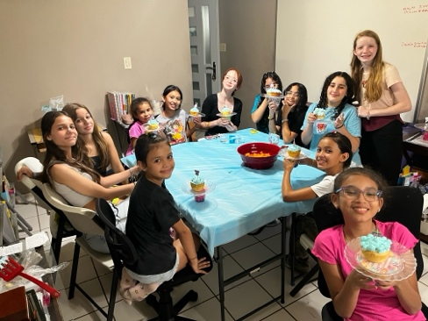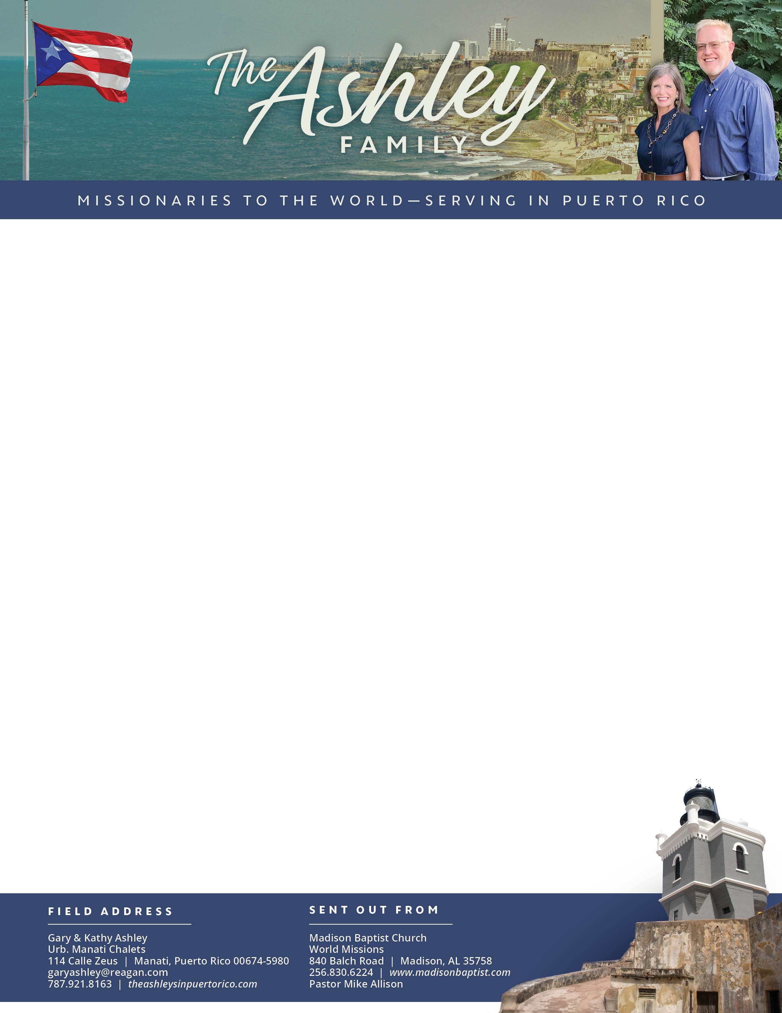

Gary Ashley

*Alaba al Señor*,

(Praise the Lord)

Prayer Requests: 1. Contacts made will come to church. 2. Charlie will visit again. 3. Abraham, Mabel, and Rosemary as they deal with their infirmed mothers.

Dear Praying Friends, May / June 2024

**Colossians 2:15 “And having spoiled principalities and powers, he made a shew of them openly, triumphing over them in it.”** In His earthly mission, Jesus not only did miracles to vindicate the message and the Messenger showing where He would conquer and how, but also did this publicly making a show of them. The church must regain its standing as a public entity and lead the culture showing to the world and others who are not so brave where and how to defeat the principalities and powers. Christ is the foundation, the goal, and also the example of public ministry.

**Evangelization Efforts:** We have been doing visitation, passing out tracts from house to house, and visiting neighbors encouraging people to come to church. This last week as I was out, I had the opportunity to speak to a woman, and she mentioned that she was looking for a Baptist church and did not know there was one in the city! We pray that she will come. I also talked to Jayson, and he said that he and his mother would like to come on Sunday. Kathy held her Girls’ Club and twelve girls attended! That is a record! We pray for these girls and their families that God’s Word will be sown in their hearts.

**Revitalization of the church building:** We have been continuing the revitalization of the church building. Through an anonymous love offering we were able to install thirteen security windows, fix a drain, and repaint one exterior wall with the letters of the church name, as well as some hard internal cleaning of calcified water stains on the tile floors. It is amazing what fresh paint and new décor do for a building! Praise the Lord for the clean, cheerful atmosphere for His Word to be preached.