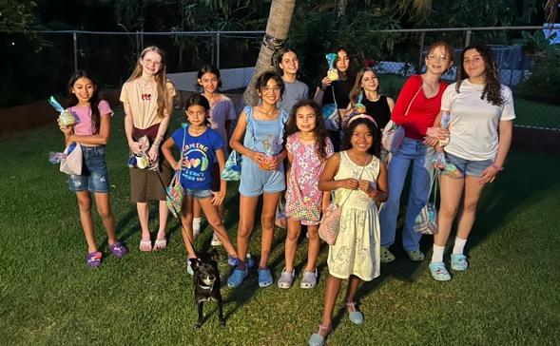

Dear Praying Friends, March / April 2025 **Daniel 5:5 “In the same hour came forth fingers of a man’s hand, and wrote over against the candlestick upon the plaister of the wall of the king’s palace: and the king saw the part of the hand that wrote.”** There are references in Scripture which show the hand of God as the power to intervene in men’s affairs as in I Samuel 5:11, but, interestingly enough, Daniel 5:5 only mentions the fingers. Consider chapter four of Daniel as the foil of the arrogance of Nebuchadnezzar with his untrue high thoughts of self about fifty years prior. By chapter five, as God saw the reign of Belshazzar, Nebuchadnezzar’s descendant, He did not even need a hand to wipe him out, but rather a couple of fingers! All power that any king or potentate has is borrowed from God. Man is admonished to fear God for He has authority. Power is often used as a weapon in the hands of evil men, but authority is revealed because the title deed belongs to God.

In some answers to prayers, Juana has still be able to attend church. Abraham has even come when she has not been able to which is a tremendous encouragement. Charlie did return to church with his daughter and he brought another visitor with him! Rene, his visitor, has traveled to the states for a month, but he promised upon return to come back to church. We pray this happens! Also, in answer to prayer, Jose has attended a few times! These many years that we have served in Manati, he has often visited our house and been witnessed to. With Stephen home working to save for school, Jose has visited church much more. Lastly, Girls’ Club was exciting! Last July we had had a record of twelve girls and this Friday, we also had twelve!! A new younger group has moved into our neighborhood, and they have been attending. God has been so good to us!

We continue to pass out tracts and invite others to come. We pray for our neighbors that one day they will visit, too, as well as reach these girls’ families for Christ.

Gary Ashley

*Alaba al Señor*,

(Praise the Lord)